Symbiosis in Nature – Student Answer Sheet
Read the descriptions of interactions and determine which type of symbiosis is occurring. Highlight/circle the correct answer. Be sure to fill in the parentheses.
 |  | Parasitism | Mutualism | Commensalism | ( ) ( )
 |  | Parasitism | Mutualism | Commensalism | ( ) ( )
 |  | Parasitism | Mutualism | Commensalism | ( ) ( )
 |  | Parasitism | Mutualism | Commensalism | ( ) ( )
 |  | Parasitism | Mutualism | Commensalism | ( ) ( )
 |  | Parasitism | Mutualism | Commensalism | ( ) ( )
 |  | Parasitism | Mutualism | Commensalism | ( ) ( )
 |  | Parasitism | Mutualism | Commensalism | ( ) ( )
 |  | Parasitism | Mutualism | Commensalism | ( ) ( )
 |  | Parasitism | Mutualism | Commensalism | ( ) ( )
 |  | Parasitism | Mutualism | Commensalism | ( ) ( )
 |  | Parasitism | Mutualism | Commensalism | ( ) ( )
 |  | Parasitism | Mutualism | Commensalism | ( ) ( )
 |  | Parasitism | Mutualism | Commensalism | ( ) ( )

- _______________________________ | - _______________________________ | - _______________________________
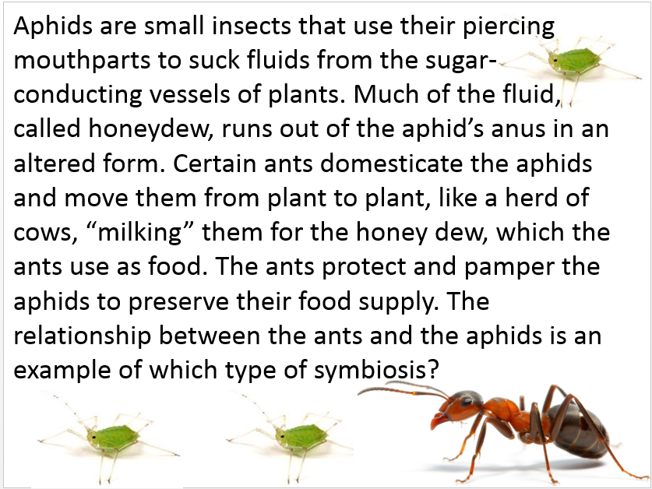 | 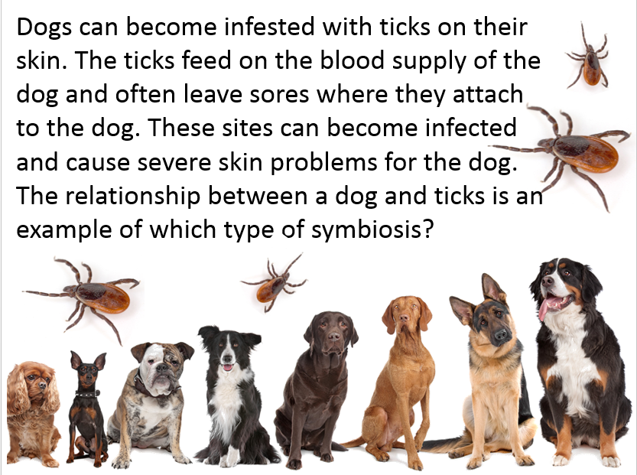 | 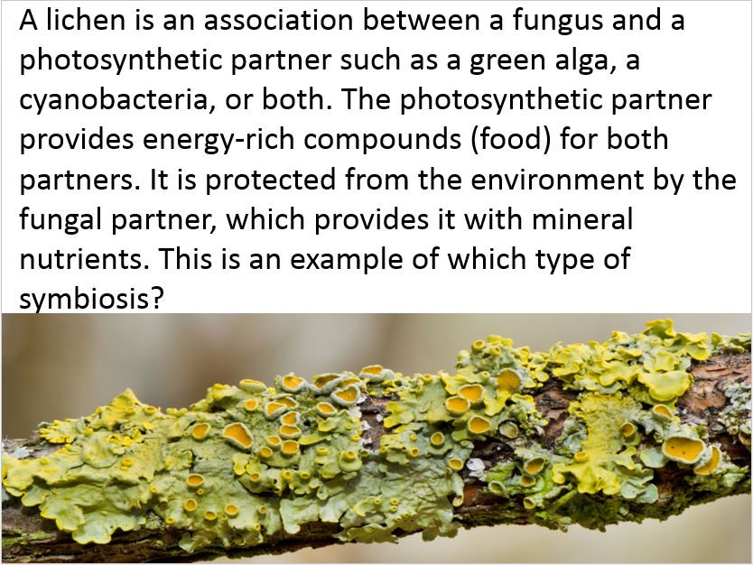
- _______________________________ |  | - The relationship between the two wasps is an example of which type of symbiosis?  ______________________________  - The relationship between the Fig wasp and the fig tree is an example of what type of symbiosis?  ______________________________
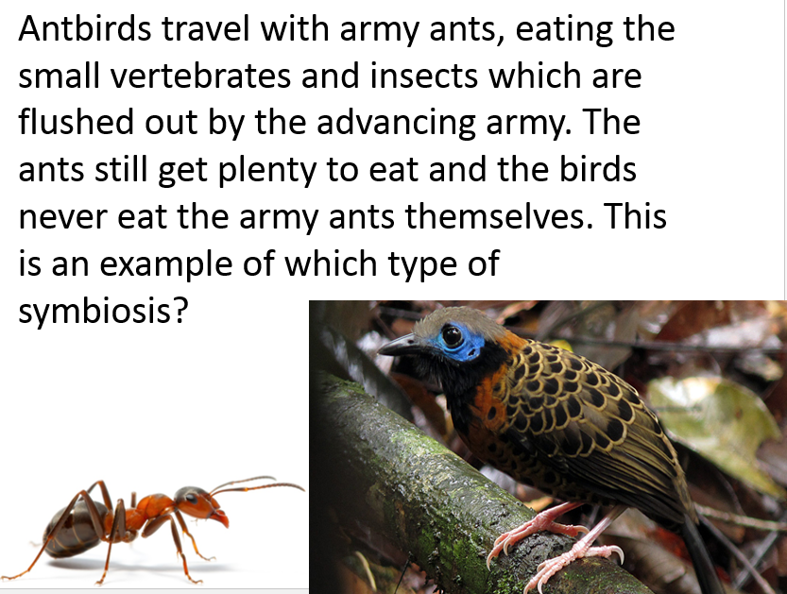 | 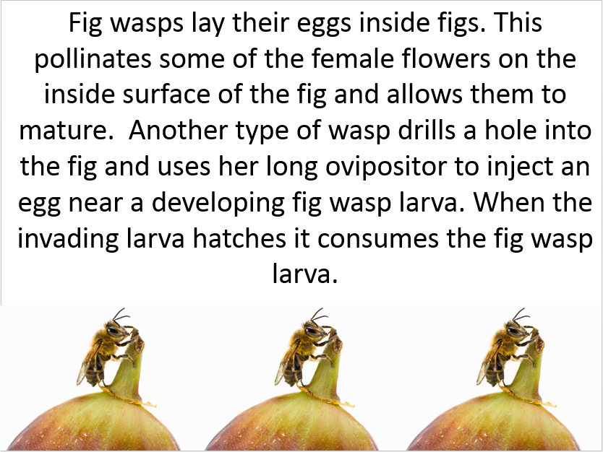

- The flower of the largest water lily in the Amazon opens at night with a bright white color. This attracts beetles, which crawl around in the flower lapping the nectar it produces. At dawn the flower closes, imprisoning the beetles. This ensures that they will be well-coated with pollen when they are released the following night. To prevent the beetles from pollinating the same flower, the flower changes to a beautiful pink, this does not temp the beetles to return. This is an example of which type of symbiotic relationship?

- There is a special relationship between remoras, also known as shark suckers, and sharks and rays. The dorsal fin of the remora is specially modified to form a sucking apparatus that is used for attachment to the host. The remora saves energy due to its limited swimming and obtains food scraps when its host is feeding. This is an example of which type of symbiotic relationship?

- Phylum Platyhelminthese, class Cestoda has a member commonly called tapeworms. These worms mostly live attached to the intestinal walls of vertebrates such as cats, rabbits and even humans. Humans often get beef tapeworms from the 1% of U.S. cattle that have them when the meat has not been cooked at high enough heat. The tapeworm feeds directly through its skin by absorbing food form the intestines of the animal they inhabit, thus depriving the animal of some nutrients. This is an example of which type of symbiotic relationship?

- Sloth hairs are grooved, which allows algae to easily take hold and grow on the sloth’s fur. This camouflages the sloth and allows the algae to get closer to the sunlight. Bacteria and protozoans inhabit the guts of sloths, breaking down the plant cellulose which would otherwise be indigestible to the larger animal. This is an example of which type of symbiotic relationship?

- There is no wind on the forest floor. For a fungus to disperse spores by the wind, it has to have a way to rise above the rainforest floor. Many kinds of decomposers and scavengers of the insect world will incidentally ingest a spore of a certain fungus. As the hyphae grow through the animal’s tissues they drive it insane, the insect climbs a tall plant and walks out to the tip of a leaf and dies as the fruiting bodies of the fungus burst through its back, dispersing its spores in the breeze from its new, exposed position. This is an example of which type of symbiotic relationship?

- The Brazil nut is an important source of food for the agouti. The agouti bites open the tough outer shell and eats the nuts inside. Sometimes it buries some of the seeds for later use, and forgets where they all are. Some of these seeds will have the chance to germinate. Without the gnawing of the agouti, the Brazil nut would be unable to germinate through the extremely hard shell. This is an example of which type of symbiotic relationship?

- Perhaps the best documented case of symbiosis is the one involving the anemone fishes called clownfish that dwell among the tentacles of tropical sea anemones. The latter animals are capable of stinging most fishes, but the anemone fishes secrete a special mucous coating that somehow prevents the discharge of the anemone’s stinging cells. The fish is protected from predators by the stinging cells. It has been suggested that they also serve as decoys that lure fishes into the deadly tentacles of the anemone, thus providing anemone’s food. However, studies in nature indicate that this does not occur. Most of the large tropical anemones feed mainly on plankton that is swept into the tentacles by currents. With all this in mind, what type of symbiotic relationship is represented?

- Blood flukes (flatworms) of the genus Schistosoma are responsible for schistosomiasis in humans. They live in the blood vessels of individuals and cause bleeding of the intestinal wall and decay of the liver due to blocked passages. The life cycle of the blood flukes includes a particular species of snail as an intermediate host. Most blood fluke infestations of people occur in tropical countries, particularly in Asia and Africa. This is an example of which type of symbiotic relationship?

