Directions: Use the following tables to answer the questions on the back of this page.
Common Name | House Cat | Lion  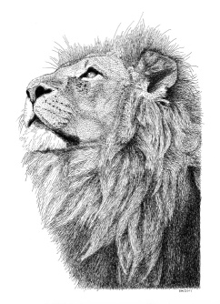 | Leopard  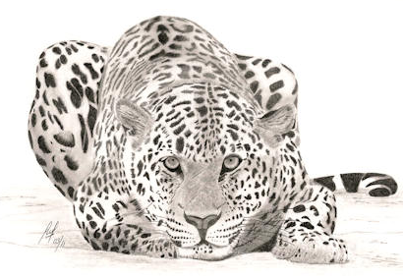 | Gray Wolf  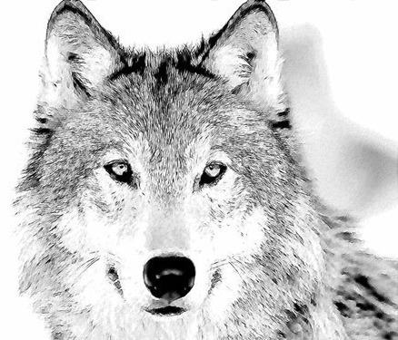
Domain | Eukaryota | Eukaryota | Eukaryota | Eukaryota
Kingdom | Animalia | Animalia | Animalia | Animalia
Phylum | Chordata | Chordata | Chordata | Chordata
Class | Mammalia | Mammalia | Mammalia | Mammalia
Order | Carnivora | Carnivora | Carnivora | Carnivora
Family | Felidae | Felidae | Felidae | Canidae
Genus | Felis | Felis | Panthera | Canis
Species | domesticus | leo | pardus | lupus

Common Name | Human | Box Turtle  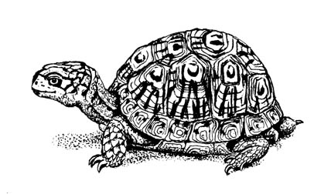 | Banded Mosquito  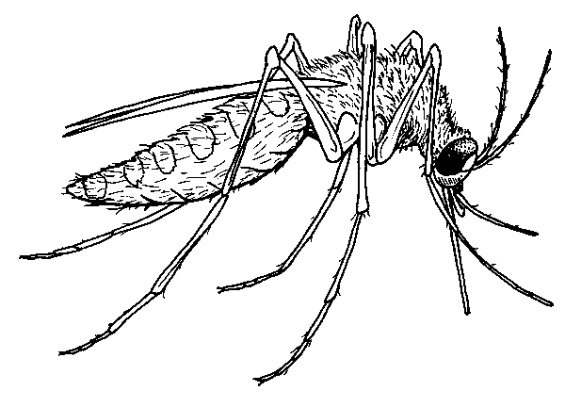 | White Oak
Domain | Eukaryota | Eukaryota | Eukaryota | Eukaryota
Kingdom | Animalia | Animalia | Animalia | Plantae
Phylum | Chordata | Chordata | Arthropoda | Tracheophyta
Class | Mammalia | Reptilia | Insecta | Angiosperm
Order | Primates | Chelonia | Diptera | Fagales
Family | Hominidae | Emydidae | Culicidae | Fagacea
Genus | Homo | Terrapene | Theobaldia | Quercus
Species | sapiens | carolina | annulata | alba
Directions: Answer the following questions using the tables from the front of this page.
- The broadest and largest category of classification is the: ________________.
- The smallest or most specific category of classification is the: ____________.
- All of the organisms except for the _____________ are in the kingdom Animalia.
- Which kingdom is the tree in? __________________
- Which kingdom is the lion in? __________________
- The third largest category of classification is phylum. Which phylum are we (humans) in? ____________________
- All of the animals except for the ___________________ are in the phylum __________________.
- The animals in the phylum chordata all have a backbone. Does a turtle have a backbone? _________
- The phylum Tracheophyta means plant that pumps water up into its leaves. Which organism is in this phylum? __________________________
- The fourth category is the class. Which class are mosquitoes in? __________
- Which class are box turtles in? __________________
- Which class are humans in? ____________________
- Name another organism in the same class as humans, _________________.
- White Oak Trees are in the class ___________________. This means they produce flowers.
- The next classification is order. Name four animals in the same order.
____________,_______________,________________, ______________
- Apes and humans share the same order, which means animals that stand on two feet. Which order is this? _____________________
- The sixth category of classification is family. Are dogs and cats in the same family? ____________
- Which family are house cats in? ______________________
- Are all cats in this family? _________________
- The seventh category of classification is genus. Animals in the same genus are closely related. Which animals share the same genus?
_________ and the __________
- The last and smallest category of classification is called __________.
- What is the species name for humans? _______________
- The genus and species make up the scientific name. What is the scientific name for humans? _____________________________
- What is the scientific name for a house cat? ________________________
- Which two organisms are most closely related? ________________ and ______________ How do you know? ______________________________________________________________________________ ________________________________________________________________________________________________________________________________________________________________________

