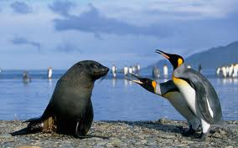
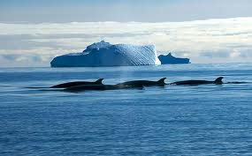
The Antarctic Ecosystem

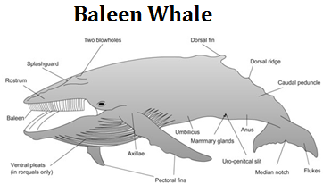
During December, the beginning of the Antarctic summer, sunlight is plentiful. Where water masses meet and winds stir the water, mixing occurs bringing vital nutrients such as nitrates and phosphates to the surface. Diatoms, a photosynthetic alga, flourish in this environment and are a major component of the oceans phytoplankton. The dominant species of zooplankton is a large crustacean, about 5cm in length, called krill. The size of krill makes it possible for them to become a food source for larger animals. Many species of fish, birds, seals and whales feed on them. Three species of seal live in this environment. The Weddell seal can dive to depths of 500 meters and feeds on fish, squid and other invertebrates, including the krill. Another seal, the Antarctic crabeater seal, does not actually eat crabs. They survive from a diet of krill. The leopard seal is a predatory seal. Its sharp fangs and large gullet are adapted for preying on penguins, which are krill-eaters, and young seals. Baleen whales, such as the right whale and the blue whale, use their extensive baleen plates to filter the water for krill. The killer whale, a toothed whale, preys on penguins and seals.

The food chains which show the flow of energy in the Antarctic ecosystem are often very long, that is, they have a number of links in the chain. Typically, the size of the consumer increases from one level to the next (example: the killer whale is larger than a penguin or seal). At every level, or link, about 9/10 of the food energy is used to maintain the animal, to keep it warm, power its motion, and is eventually converted to heat and lost. Only 1/10 of the food energy passes on to the next level.

In this exercise, you will be asked to diagram the energy relationships of the Antarctic organisms described above. You will determine which organisms have the most energy efficient production, that is, which organisms conserve the energy of the ecosystem best.

The following food chain is an example for you to follow. Remember arrows are generally used to show the direction the energy flows. In this food chain, the amount of biomass in kilograms is shown in each step of the chain. This means that it requires 100kg of diatoms for a macaroni penguin to gain 1kg as only 1/10 of the biomass produced in one level is passed on to the next.
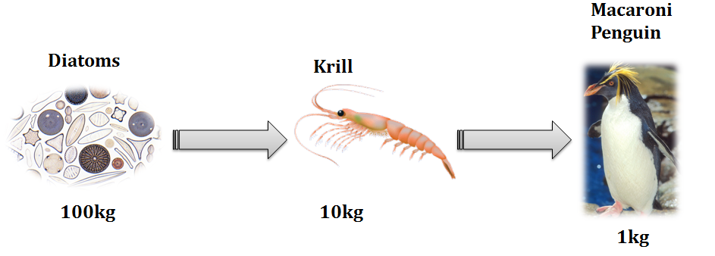

Directions: Use The Antarctic Ecosystem article and your knowledge about energy flow to answer the following questions. Be sure to use complete sentences unless asked to draw a diagram.

- Which organism is an important producer in the Antarctic Ocean? _____________________________________
- Create a food chain in which the killer whale is the top predator.

- In the space below create a four step (four organisms) food chain ending with a leopard seal.

- How many kilograms of diatoms are required for the leopard seal to gain 7.5 kilograms? ___________
- In the space below create a food chain that ends with one of the baleen whales.

- How many kilograms of diatoms are needed for the baleen whale to gain 7.5 kilograms? ____________
- Which is more energy efficient? (circle one) Leopard seal Baleen Whale
Explain your answer: _______________________________________________________________________________________ _________________________________________________________________________________________________________________
- What is the original energy source for the Antarctic food chains? ______________________________________
- Why are there fewer killer whales than leopard seals? __________________________________________________ _________________________________________________________________________________________________________________
- Why are baleen whales able to reach such enormous sizes? (blue whales can weigh between 150-170 metric tons) _____________________________________________________________________________________________ _________________________________________________________________________________________________________________

- In the space below create a food web using the organisms from this article.

- Draw and label a biomass pyramid using the food chain from number 3.

- Explain its shape and what happens to the energy at each step of the pyramid.
SHAPE:_________________________________________________________________________________________________________________________________________________________________________________________________________________________ENERGY:_______________________________________________________________________________________________________________________________________________________________________________________________________________________

- The Russians, who traditionally hunt whales as a food source, are currently experimenting in harvesting krill as a human food source. What do you think about this? Can you see any advantages to the ecosystem in harvesting krill? _________________________________________________________ ____________________________________________________________________________________________________________________________________________________________________________________________________________________________________________________________________________________________________________________________________________________________________________________________________________________________________________________________________

